Implementation and Performance Evaluation of a CNN-Based Deep Learning Model for IoE Edge Applications
Objective:
To implement a CNN for handwritten digit classification on the MNIST dataset and evaluate its suitability for IoE edge applications using accuracy, confusion matrix, sample predictions, timing and model size.
Procedure:
- Load MNIST (60,000 training and 10,000 test images of 28 x 28 pixels) and normalise pixels to 0-1.
- Build the CNN: two Conv2D + MaxPooling blocks, a Dense(128) layer and a 10-class softmax output (225,034 parameters).
- Compile with the Adam optimizer and sparse categorical cross-entropy; train for 5 epochs, batch size 64, 10% validation split.
- Evaluate on the test set; plot accuracy and loss curves; generate the confusion matrix, classification report and sample predictions.
Program:
import tensorflow as tf
import matplotlib.pyplot as plt
import numpy as np
import seaborn as sns
from sklearn.metrics import confusion_matrix, classification_report

# 1. Load MNIST dataset
(x_train, y_train), (x_test, y_test) = tf.keras.datasets.mnist.load_data()

# 2. Preprocess images
x_train = x_train.reshape(-1, 28, 28, 1).astype('float32') / 255.0
x_test = x_test.reshape(-1, 28, 28, 1).astype('float32') / 255.0

# 3. Build CNN model
model = tf.keras.Sequential([
tf.keras.layers.Input(shape=(28, 28, 1)),
tf.keras.layers.Conv2D(32, (3, 3), activation='relu'),
tf.keras.layers.MaxPooling2D((2, 2)),
tf.keras.layers.Conv2D(64, (3, 3), activation='relu'),
tf.keras.layers.MaxPooling2D((2, 2)),
tf.keras.layers.Flatten(),
tf.keras.layers.Dense(128, activation='relu'),
tf.keras.layers.Dense(10, activation='softmax')
])

# 4. Compile model
model.compile(
optimizer='adam',
loss='sparse_categorical_crossentropy',
metrics=['accuracy']
)

# 5. Train model
history = model.fit(
x_train, y_train,
epochs=5,
batch_size=64,
validation_split=0.1
)

# 6. Evaluate model
test_loss, test_accuracy = model.evaluate(
x_test, y_test, verbose=0
)
print(f"Test Accuracy: {test_accuracy * 100:.2f}%")

# 7. Plot accuracy vs epoch
epochs = range(1, len(history.history['accuracy']) + 1)

plt.figure(figsize=(8, 5))
plt.plot(epochs, history.history['accuracy'],
marker='o', label='Training Accuracy')
plt.plot(epochs, history.history['val_accuracy'],
marker='s', label='Validation Accuracy')
plt.title('Accuracy vs Epoch')
plt.xlabel('Epoch')
plt.ylabel('Accuracy')
plt.xticks(list(epochs))
plt.legend()
plt.grid(True)
plt.tight_layout()
plt.show()

# 8. Plot loss vs epoch
plt.figure(figsize=(8, 5))
plt.plot(epochs, history.history['loss'],
marker='o', label='Training Loss')
plt.plot(epochs, history.history['val_loss'],
marker='s', label='Validation Loss')
plt.title('Loss vs Epoch')
plt.xlabel('Epoch')
plt.ylabel('Loss')
plt.legend()
plt.grid(True)
plt.tight_layout()
plt.show()

# 9. Predict all test images
probabilities = model.predict(x_test, batch_size=256, verbose=0)
y_pred = np.argmax(probabilities, axis=1)

# 10. Confusion matrix
cm = confusion_matrix(y_test, y_pred)

plt.figure(figsize=(9, 7))
sns.heatmap(
cm,
annot=True,
fmt='d',
cmap='Blues',
xticklabels=range(10),
yticklabels=range(10)
)
plt.title('CNN Digit Classification - Confusion Matrix')
plt.xlabel('Predicted Digit')
plt.ylabel('Actual Digit')
plt.tight_layout()
plt.show()

# 11. Classification report
print("\nClassification Report:")
print(classification_report(y_test, y_pred, digits=4))

# 12. Display three example predictions
indices = [0, 1, 2]

plt.figure(figsize=(9, 3))
for i, idx in enumerate(indices):
plt.subplot(1, 3, i + 1)
plt.imshow(x_test[idx].squeeze(), cmap='gray')
plt.title(
f"Actual: {y_test[idx]}\nPredicted: {y_pred[idx]}"
)
plt.axis('off')

plt.suptitle('Three Example Predictions')
plt.tight_layout()
plt.show()

# 13. Print three predictions
print("\nThree Example Predictions:")
for i, idx in enumerate(indices):
print(f"Example {i+1}: Actual = {y_test[idx]}, "
f"Predicted = {y_pred[idx]}")

Results:
Epoch | Train acc | Train loss | Val acc | Val loss | Time (s)
1 | 0.9496 | 0.1666 | 0.9845 | 0.0550 | 47
2 | 0.9856 | 0.0469 | 0.9890 | 0.0383 | 46
3 | 0.9893 | 0.0326 | 0.9905 | 0.0333 | 44
4 | 0.9918 | 0.0244 | 0.9898 | 0.0384 | 89
5 | 0.9946 | 0.0169 | 0.9917 | 0.0321 | 46
Total |  |  |  |  | 272

Metric | Value
Training time (5 epochs) | 272 s (4 min 32 s), about 54 ms/step
Testing time (10,000 images) | ____ s (measure with the code below)
Test accuracy | 99.05% (9,905 of 10,000 correct)
Macro avg precision / recall / F1 | 0.9904 / 0.9904 / 0.9904
Model size | 225,034 parameters, about 0.9 MB (float32)

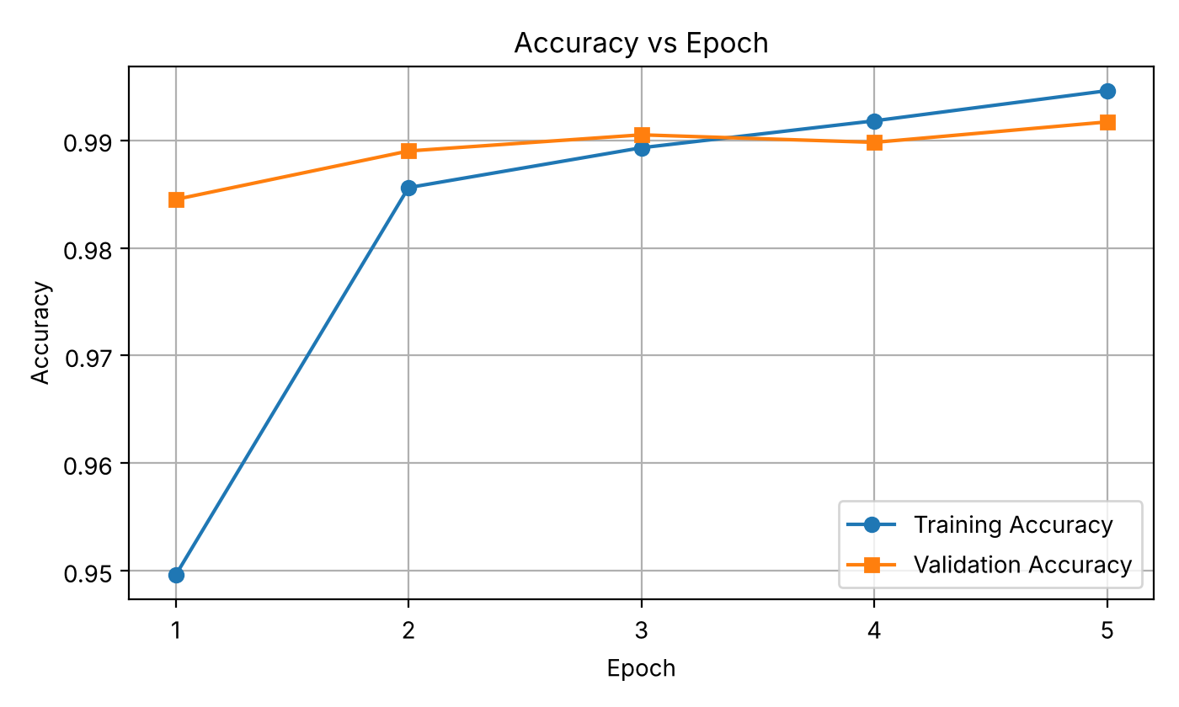
Fig. 1: Accuracy vs Epoch
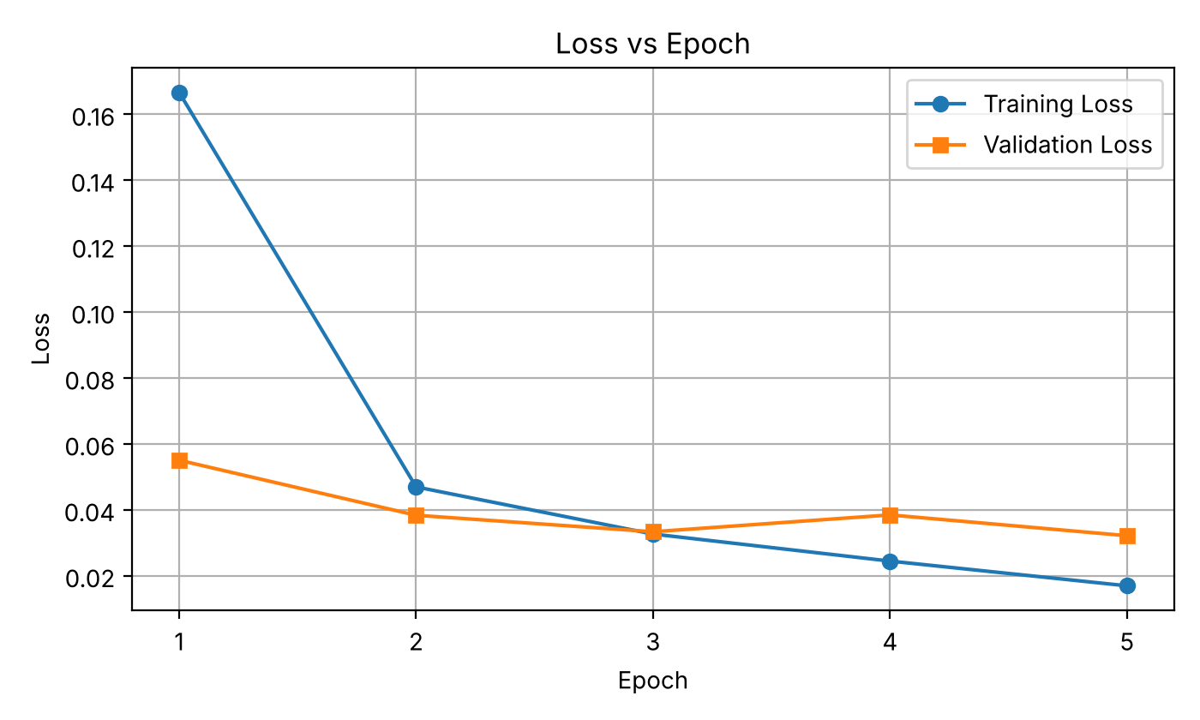
Fig. 2: Loss vs Epoch
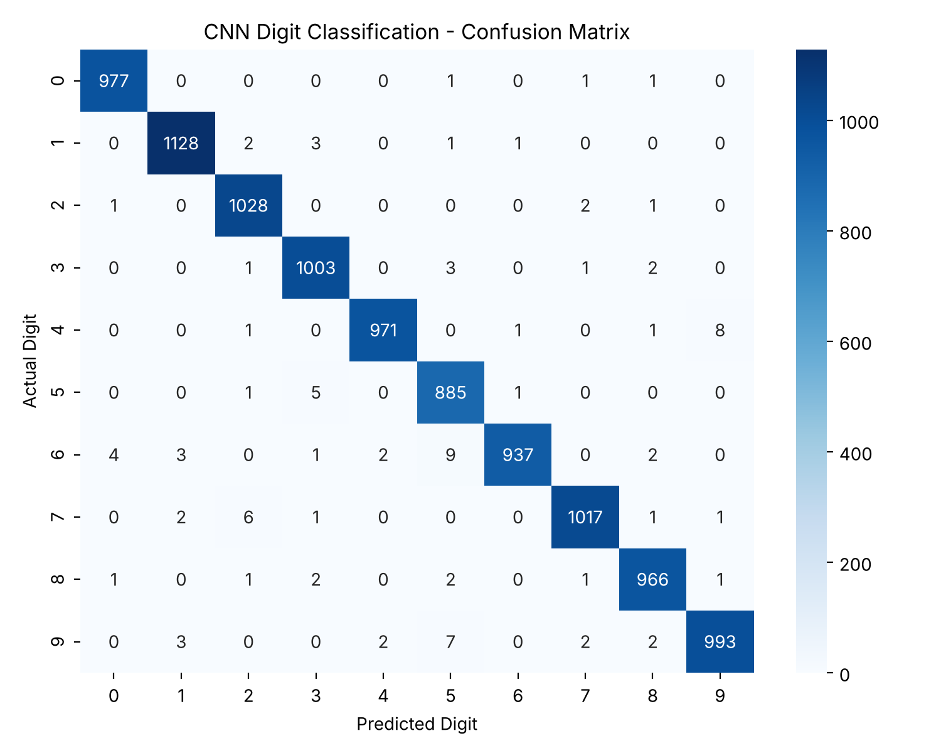
Fig. 3: Confusion matrix on the test set
The 95 errors are spread thinly; the largest confusions are 6 predicted as 5 (9 images) and 4 predicted as 9 (8 images). Every class has precision and recall above 97%.
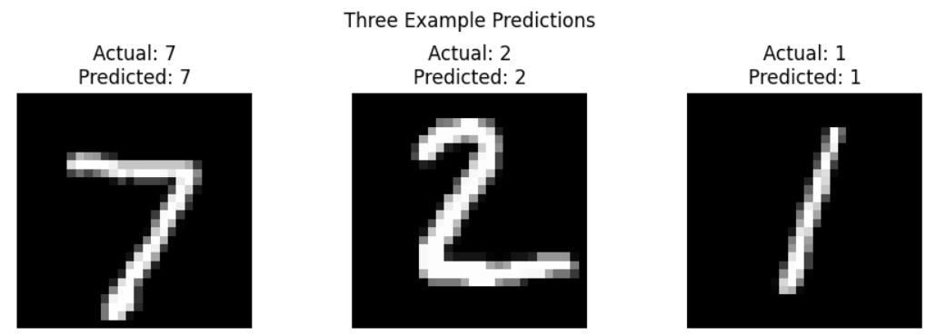
Fig. 4: Three example predictions (Actual 7, 2, 1 predicted as 7, 2, 1)
Result:
The CNN reached 99.05% test accuracy after 5 epochs (about 4.5 minutes of training), with training and validation curves close together, so there is no significant overfitting. All three example predictions were correct. With only 225,034 parameters (about 0.9 MB), the model is small enough to run on edge devices, so data can be classified locally without sending it to the cloud, which reduces latency and bandwidth use in IoE applications.

